Team Nature Proposal

Derrick Lor, Jason Huang, Joseph Kolenchery, Aiman Baig

Our proposed interface falls in the category of connecting with nature. It seeks to inform tourists about the natural scenery of the land by constructing a photo journal documenting their adventure and experiences. Users can plan their own adventures or go on a virtual experience through the eyes of their peers. This interface will allow deeper insight into behind the scenes unlike many curated photos found online. For example, a picture on google will look much better than it is, whereas with the idea of other tourists constructing a photo journal will give a genuine idea to another tourist. This allows users to better structure time and make decisions based on real world experiences of other people.

The problem this interface tries to gap is the burden of uncertainty associated with travel. By giving tourists, a better experience through recent exposure from another tourist, it solves the lack of reliable information on the web when planning a trip. Conventional tourism relies on cherry-picked photographs posted online which could potentially be misleading. For instance, Los Angeles downtown Hollywood Walk of Fame is rated 4 stars, whereas when a tourist goes there from other threads, they describe it in an extremely negative tone making it misleading to tourists. The intended target population are people who travel and have interests in exploring nature. Many travelers would enjoy “hidden gems,” if there had been someone to document the location and spread awareness. The goal of the interface is to initiate or enhance a traveler’s journey by building a genuine, legitimate, honest recollection of another traveler’s experience.

The target demographic encompasses all tourists for all types of journeys, including self-guided tours, expeditions, small families, and solo adventurers. The interface will allow users to record their trips with text, photos, or short videos along the way. Review past trips and share their experiences with their friends and family. No matter which kind of journey or type of user, this travel journal exists to cherish trip memories. Whether the user wants to share their experience or simply wants to document their trips for their own enjoyment, this interface provides a platform and tools that do more than a simple digital album can achieve.

The main idea behind our project is based off TripAdvisor. Although, unlike TripAdvisor, we are aiming for the users to share a directory which includes pictures, locations, expenses and all the other activities and resources that were involved along the journey. Users will have the option to interact and exchange journals to get tips on how to maximize their experience.

The stakeholders pursuing this interface would highly be investors who travel plentiful number of times as they both have the purpose to build a better interface for their travel journeys. The Quadrant Stakeholder Map provides a great explanation from both influence as well as interest to create an interface that would work in their favor. For example, travelers would have a high impact in interest because they are the main audience who would use such an interface. Secondly, Investors would be a major influence on the interface when utilized by a tourist or themselves.

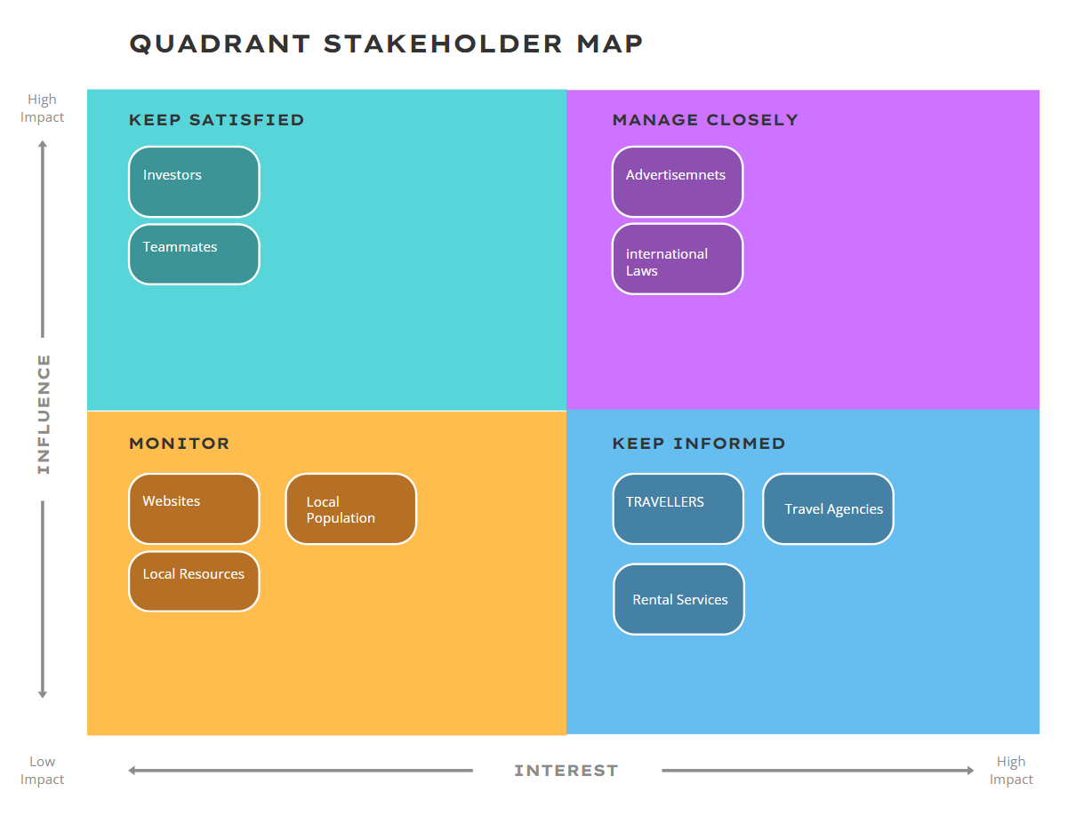

Overall, the main goal is to market to those who tend to travel in nature and give a better experience when researching into an area with great scenery. The timeline below provides an in-depth description of how the project will be conducted. Each step gives an idea of what needs to be done to get this interface running for those who tend to research in great areas for their all-season travels.

**Timeline**

|  |  |
| --- | --- |
| **Tentative Date** | **Objectives** |
| Mar 15 | Submit proposal – Team Nature |
| Mar 16 – Mar 19 | Background research – Investigate existing solutions and potential improvements to the solutions  Mar 19: In-class pitch |
| Mar 20 – Mar 26 | Need finding research – Interview target population  Affinity diagram – Sort out the notes from interviews |
| Mar 27 – Mar 30 | Determine the tasks – Discuss available actions and requirements of our underlying model from the affinity diagram |
| Apr 1 – Apr 5 | Create a low-fidelity prototype  Apr 4: Mid-project presentation |
| Apr 8 – Apr 12 | Evaluate the usability and refine the prototype |
| Apr 15 – Apr 19 | Improve and finalize the hi-fi prototype |
| Apr 22 – Apr 26 | Complete the final report  Apr 25: Final presentation |

<https://www.mdpi.com/1911-8074/16/3/210>

<https://link.springer.com/chapter/10.1007/978-3-031-31513-8_17>

<https://www.sciencedirect.com/science/article/pii/S2213078023000646>

**References**

Ana María Campón-Cerro, Bárbara Sofía Pasaco-González, José Manuel Hernández-Mogollón,

& Elide Di-Clemente. (2023). Exploring the Role of Authenticity and Frequency of Participation on Tourists’ Quality of Life in Nature-Based Experiences. International Handbooks of Quality-of-Life, 237–251. <https://doi.org/10.1007/978-3-031-31513-8_17>

Helal, Emad Ahmed, et al. “Exploration or Exploitation of a Neighborhood Destination: The

Role of Social Media Content on the Perceived Value and Trust and Revisit Intention among World Cup Football Fans.” Journal of Risk and Financial Management, vol. 16, no. 3, 22 Mar. 2023, p. 210, www.mdpi.com/1911-8074/16/3/210, <https://doi.org/10.3390/jrfm16030210>.

Nautiyal, R., Polus, R., Tripathi, A., & Shaheer, I. (2023). "To use or not to use" - Mobile

technology in nature-based tourism experience. Journal of Outdoor Recreation and Tourism, 43, 100667. <https://doi.org/10.1016/j.jort.2023.100667>